

**VISA PLATINUM**

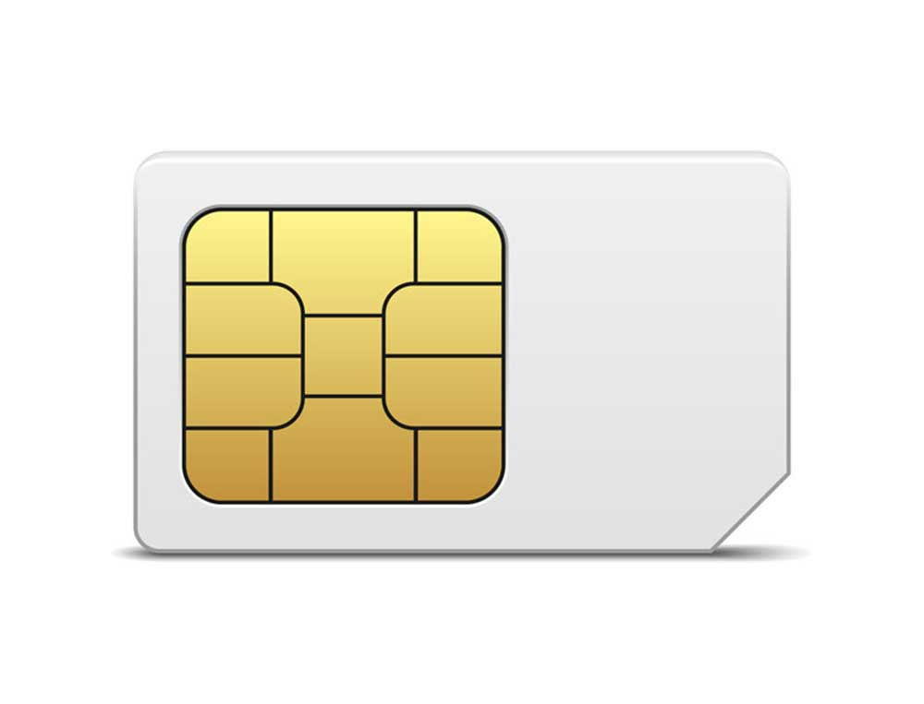

**7782 3665 6655 4433**

**SHIV MOHAN 16/2050**

**VISA**